Experiment No.: 7
1.Title: Perform DOM traversal and updates; develop a to-do list app with add, edit, and delete features.
2. Software/Tools Required: VSC,HTML,CSS
3. Theory: DOM traversal allows JavaScript to select and navigate HTML elements, while DOM manipulation allows adding, editing, and deleting elements dynamically. A To-Do List uses these concepts to add new tasks, edit existing tasks, and delete completed or unwanted tasks without reloading the webpage.
Code:
Index.html:
<!DOCTYPE html>
<html lang="en">
<head>
<meta charset="UTF-8">
<meta name="viewport" content="width=device-width, initial-scale=1.0">
<title>To-Do List App</title>
<link rel="stylesheet" href="style.css">
</head>

<body>

<div class="app">

<h1>Ayushi Ray: 145</h1>

<!-- Create New List -->
<div class="new-list">
<input type="text" id="listInput" placeholder="Enter list name">
<button onclick="addList()">+ Add List</button>
</div>

<!-- Lists -->
<div class="lists" id="listsContainer"></div>

<!-- Current List -->
<div class="todo-section">

<div class="list-header">
<h2 id="currentListName">Select a List</h2>
<button onclick="deleteCurrentList()" class="delete-list">
Delete List
</button>
</div>

<!-- Add Task -->
<div class="task-input">
<input
type="text"
id="taskInput"
placeholder="Enter a task"
>
<button onclick="addTask()">Add Task</button>
</div>

<!-- Tasks -->
<ul id="taskList"></ul>

<!-- Undo -->
<button onclick="undo()" class="undo-btn">
↩ Undo
</button>

</div>

</div>

<script src="script.js"></script>

</body>
</html>
Style.css:
* {
margin: 0;
padding: 0;
box-sizing: border-box;
font-family: Arial, sans-serif;
}

body {
background: #f4f6f8;
min-height: 100vh;
padding: 40px;
}

.app {
max-width: 900px;
margin: auto;
background: white;
padding: 30px;
border-radius: 15px;
box-shadow: 0 5px 20px rgba(0,0,0,0.1);
}

h1 {
text-align: center;
margin-bottom: 30px;
}

/* Create List */

.new-list {
display: flex;
gap: 10px;
margin-bottom: 25px;
}

input {
padding: 12px;
border: 1px solid #ccc;
border-radius: 6px;
outline: none;
}

.new-list input {
flex: 1;
}

button {
border: none;
padding: 12px 18px;
border-radius: 6px;
cursor: pointer;
background: #007bff;
color: white;
}

button:hover {
opacity: 0.85;
}

/* Lists */

.lists {
display: flex;
gap: 10px;
flex-wrap: wrap;
margin-bottom: 30px;
}

.list-btn {
background: #e9ecef;
color: #333;
}

.list-btn.active {
background: #007bff;
color: white;
}

/* Todo Section */

.todo-section {
border-top: 1px solid #ddd;
padding-top: 25px;
}

.list-header {
display: flex;
justify-content: space-between;
align-items: center;
margin-bottom: 20px;
}

.delete-list {
background: #dc3545;
}

/* Add Task */

.task-input {
display: flex;
gap: 10px;
margin-bottom: 20px;
}

.task-input input {
flex: 1;
}

/* Tasks */

#taskList {
list-style: none;
}

.task {
display: flex;
align-items: center;
justify-content: space-between;
background: #f1f3f5;
padding: 12px;
margin-bottom: 10px;
border-radius: 7px;
}

.task.completed .task-text {
text-decoration: line-through;
color: gray;
}

.task-left {
display: flex;
align-items: center;
gap: 10px;
}

.task-text {
font-size: 16px;
}

/* Task Buttons */

.task-actions {
display: flex;
gap: 5px;
}

.edit-btn {
background: #ffc107;
color: black;
}

.delete-btn {
background: #dc3545;
}

.undo-btn {
margin-top: 15px;
background: #6c757d;
}
Script.js:
let lists = JSON.parse(localStorage.getItem("todoLists")) || [];

let currentListId = null;

let history = [];

function saveData() {
localStorage.setItem("todoLists", JSON.stringify(lists));
}

function addList() {

const input = document.getElementById("listInput");

const name = input.value.trim();

if (name === "") {
alert("Enter a list name.");
return;
}

const newList = {
id: Date.now(),
name: name,
tasks: []
};

lists.push(newList);

saveData();

input.value = "";

currentListId = newList.id;

renderLists();
renderTasks();
}

function selectList(id) {

currentListId = id;

renderLists();
renderTasks();
}

function getCurrentList() {

return lists.find(list => list.id === currentListId);
}

function addTask() {

if (currentListId === null) {
alert("First create or select a list.");
return;
}

const input = document.getElementById("taskInput");

const text = input.value.trim();

if (text === "") {
alert("Enter a task.");
return;
}

const list = getCurrentList();

// Save previous state for Undo
saveHistory();

list.tasks.push({
id: Date.now(),
text: text,
completed: false
});

saveData();

input.value = "";

renderTasks();
}

function editTask(taskId) {

const list = getCurrentList();

const task = list.tasks.find(task => task.id === taskId);

if (!task) return;

const newText = prompt("Edit your task:", task.text);

if (newText === null) {
return;
}

if (newText.trim() === "") {
alert("Task cannot be empty.");
return;
}

saveHistory();

task.text = newText.trim();

saveData();

renderTasks();
}

function deleteTask(taskId) {

const list = getCurrentList();

saveHistory();

list.tasks = list.tasks.filter(
task => task.id !== taskId
);

saveData();

renderTasks();
}

function toggleTask(taskId) {

const list = getCurrentList();

const task = list.tasks.find(
task => task.id === taskId
);

if (!task) return;

saveHistory();

task.completed = !task.completed;

saveData();

renderTasks();
}

function deleteCurrentList() {

if (currentListId === null) {
return;
}

const list = getCurrentList();

const confirmDelete = confirm(
`Delete "${list.name}" list?`
);

if (!confirmDelete) {
return;
}

saveHistory();

lists = lists.filter(
list => list.id !== currentListId
);

currentListId = null;

saveData();

renderLists();
renderTasks();
}

function saveHistory() {

history.push(
JSON.stringify(lists)
);

// Keep only last 10 actions
if (history.length > 10) {
history.shift();
}
}

function undo() {

if (history.length === 0) {
alert("Nothing to undo.");
return;
}

const previousState = history.pop();

lists = JSON.parse(previousState);

saveData();

// Check if current list still exists
const exists = lists.some(
list => list.id === currentListId
);

if (!exists) {

if (lists.length > 0) {
currentListId = lists[0].id;
} else {
currentListId = null;
}
}

renderLists();
renderTasks();
}

function renderLists() {

const container =
document.getElementById("listsContainer");

container.innerHTML = "";

lists.forEach(list => {

const button = document.createElement("button");

button.textContent = list.name;

button.className = "list-btn";

if (list.id === currentListId) {
button.classList.add("active");
}

button.onclick = function () {
selectList(list.id);
};

container.appendChild(button);
});
}

function renderTasks() {

const title =
document.getElementById("currentListName");

const taskList =
document.getElementById("taskList");

taskList.innerHTML = "";

const deleteListButton =
document.querySelector(".delete-list");

if (currentListId === null) {

title.textContent = "Select a List";

deleteListButton.style.display = "none";

return;
}

const list = getCurrentList();

title.textContent = list.name;

deleteListButton.style.display = "block";

list.tasks.forEach(task => {

const li = document.createElement("li");

li.className = "task";

if (task.completed) {
li.classList.add("completed");
}

// Left section
const left = document.createElement("div");

left.className = "task-left";

// Checkbox
const checkbox =
document.createElement("input");

checkbox.type = "checkbox";

checkbox.checked = task.completed;

checkbox.onchange = function () {
toggleTask(task.id);
};

// Task text
const span =
document.createElement("span");

span.textContent = task.text;

span.className = "task-text";

left.appendChild(checkbox);
left.appendChild(span);

// Buttons
const actions =
document.createElement("div");

actions.className = "task-actions";

// Edit
const editButton =
document.createElement("button");

editButton.textContent = "Edit";

editButton.className = "edit-btn";

editButton.onclick = function () {
editTask(task.id);
};

// Delete
const deleteButton =
document.createElement("button");

deleteButton.textContent = "Delete";

deleteButton.className = "delete-btn";

deleteButton.onclick = function () {
deleteTask(task.id);
};

actions.appendChild(editButton);
actions.appendChild(deleteButton);

li.appendChild(left);
li.appendChild(actions);

taskList.appendChild(li);
});
}

if (lists.length > 0) {

currentListId = lists[0].id;
}

renderLists();
renderTasks();

4.Output:
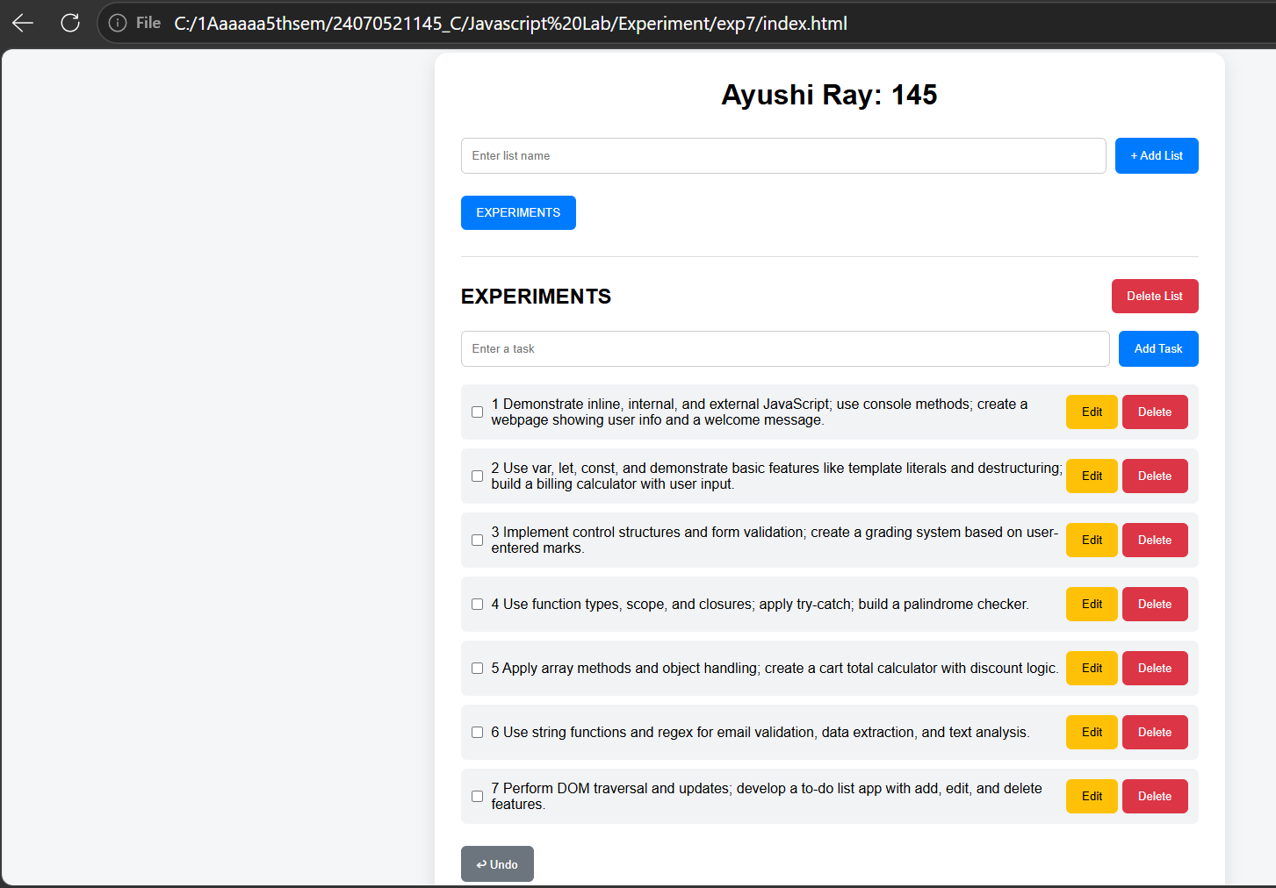
5.Result: The shopping cart application was successfully developed using HTML, CSS, and JavaScript. It provides an interactive e-commerce interface where users can browse products, search items, add or remove products, modify quantities, and view the cart summary. The application dynamically calculates the total amount, applicable discount, and final payable amount using JavaScript array methods and object handling.

